Honda

Information Services

AF Test Client
Error! Unknown document property name.

Creation Date: 9/7/2011 2:56:00 PM

Last Saved: 9/9/2011 6:52:00 PMPM

TABLE OF CONTENTS

1. Revision History 2
2. Document Overview 4
2.1. Referenced Documents 4
2.2. Acronym List 4
3. Environment 4
4. Test Execution 5
4.1. Test Case 1 – Normal Flow to test the working condition of the Torque Guns 5
4.1.1 Pre-Conditions 5
4.1.2 Purpose: 5
4.1.3 What’s accomplished? 5
4.1.4 Test Steps 5
4.1.5 Post-Conditions 13
4.2. Test Case 2 – Change to a different tab before closing the lot control client information screen 13
4.2.1 Pre-Conditions 13
4.2.2 Purpose: 13
4.2.3 What’s accomplished? 13
4.2.4 Test Steps 14
4.2.5 Post-Conditions 22
4.3. Test Case 3 – Controller pset is reset correctly after closing the test client 22
4.3.1 Pre-Conditions 22
4.3.2 Purpose: 22
4.3.3 What’s accomplished? 22
4.3.4 Test Steps 23
4.3.5 Post-Conditions 30
4.4. Test Case 4 – Controller Pset is reset correctly after switching tabs before closing the test client 31
4.4.1 Pre-Conditions 31
4.4.2 Purpose: 31
4.4.3 What’s accomplished? 31
4.4.4 Test Steps 31
4.4.5 Post-Conditions 39

Revision History
Revision | Section | Description | Editor | Date
1.0 | All | Original | Ganga | 10/14/08
Reviewers
Name | Position | Version | Comments
Approval Signatures
Name | Position | Version | Signature / Date

Document Overview
This section describes the process that this test plan exercises.

Referenced Documents
The following documents are referenced as part of this document.

- None

Acronym List
- GALC – Global Auto Line Control
- HMIN – Honda Manufacturing of Indiana
- HAM – Honda of America, Mfg.
- HMA – Honda Manufacturing of Alabama
- VIN – Vehicle Identification Number
- PL – Project Lead
- WE – Weld department
- ST – Stamping department
- AF – Auto Frame department
- VQ – Vehicle Quality department

Environment
This section describes the environment that the test was executed against.

Environment | WAS Version | App Server | DB Server | OPC Server | Device

Test Execution

Test Case 1 – Normal Flow to test the working condition of the Torque Guns

Pre-Conditions
The following Pre-Conditions should be met before executing the test:
- Data setup in GAL234TBX (Terminal Table)
- Data setup in GAL246TBX (Lot Control Rule Table)
- Data setup in GAL214TBX (Process Point Table)
- Data setup in PART_SPEC_TBX (Parts Table)
- Data setup in MEASUREMENT_SPEC_TBX (Parts Table)
- Data setup in GAL143TBX (Frame table)

Purpose:
In this test case, the working condition of the Torque Guns is tested. Using this screen the user can enable and disable the Torque Guns, collect the torque values and display them in the text box.

What’s accomplished?
The successful execution of this Test Case accomplishes the following:
- Test whether user can test whether Torque Gun is working or not.

Test Steps
This section describes the steps to be taken in order to execute the test.

Step | Procedure | Expected Results | Actual Results | Pass/Fail
1 | Launch a lot control station with a torque controller | The client launches normally | As expected | Pass
2 | Click on the client information button | The lot control client information screen opens | As expected | Pass
3 | Click on the devices tab | The devices tab is displayed with a list of connected devices on the left side of the screen | As expected | Pass
4 | Select a torque device from the left side of the devices screen | The device connection information is displayed and the valid Model Year, Model Code, Model Type, Model Option, Interior Color and Exterior Color values for the process point are also auto populated in drop downs on the screen. | As expected | Pass
5 | Select the MTOC by selecting the Model Year, Model Code, Model Type, Model Option, Interior Color and Exterior Color values from their corresponding dropdowns. | The MTOC value is selected. | The MTOC value is selected. | Pass
6 | Press the “Select” Button | The Parts Names, Instruction codes for the parts, Part Serial Masks and the Minimum and Maximum torque values are displayed in the table. | The Parts Names, Instruction codes for the parts, Part Serial Masks and the Minimum and Maximum torque values are displayed in the table. | Pass
7 | Select the Part Name, for which torque value needs to be collected , from the table. | The Enable Device button , Disable Device button and Torque textbox are activated and displayed on the screen. | The Enable Device button , Disable Device button and Torque textbox are activated and displayed on the screen. | Pass
8 | Press Enable Device button | The Instruction Code is sent to the Torque Gun and Torque Gun is enabled. | The Instruction Code is sent to the Torque Gun and Torque Gun is enabled. | Pass
9 | Collect the Torque values using the Torque Gun | The Torque value is displayed in the Torque textbox. .  (Note: The Torque textbox background color changes to red or green depending on the collected torque value. If the collected torque value is with in the minimum and maximum torque value limits, the background color of the torque textbox changes to green. If the collected torque value is not with in the minimum and maximum torque value limits, the background color of the torque textbox changes to red. ) | The Torque value is displayed in the Torque textbox. .  (Note: The Torque textbox background color changes to red or green depending on the collected torque value. If the collected torque value is with in the minimum and maximum torque value limits, the background color of the torque textbox changes to green. If the collected torque value is not with in the minimum and maximum torque value limits, the background color of the torque textbox changes to red. ) | Pass
10 | Press the Disable Button | The Instruction code is sent to the Torque gun. The Torque Gun is disabled. | The Instruction code is sent to the Torque gun. The Torque Gun is disabled. | Pass
11 | Click on the close button | The lot control client information screen is closed and the torque controller is returned to the pset and enabled/disabled state it was in before the lot control client information screen was opened | As expected | Pass
12 | Execute the steps of the Regional Lot Control Test Plan normal flow and confirm that torques are received correctly by the normal GALC screen | Torque results appear on the main GALC lot control screen at the correct steps in the normal flow | Torques displayed correctly | Pass

Step 1 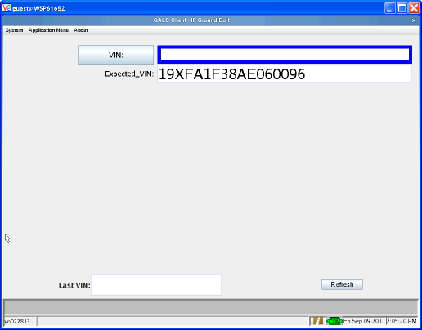

Step 2 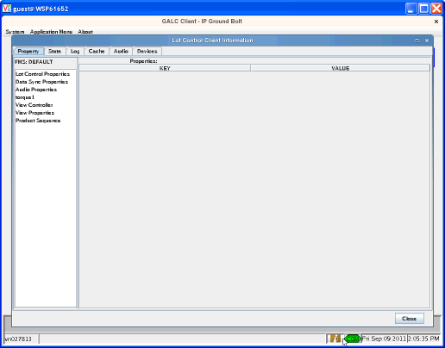

Step 3 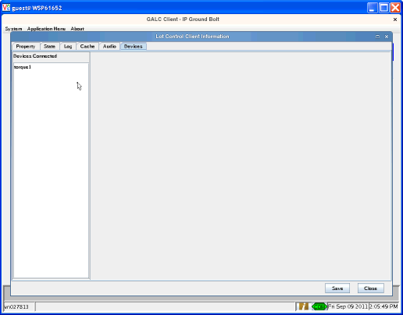

Step 4 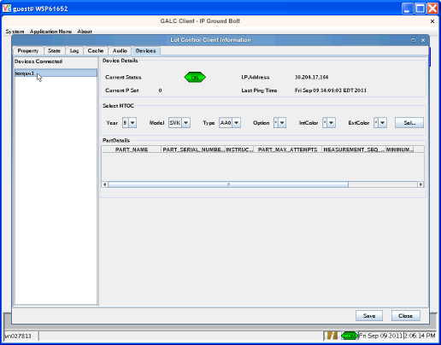

Step 6 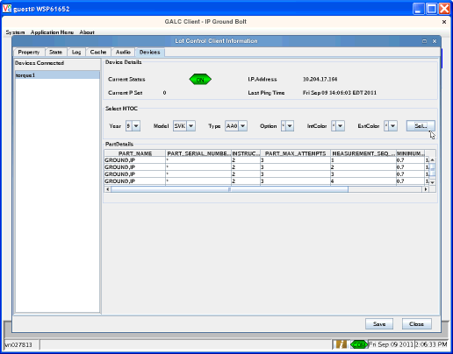

Step 7 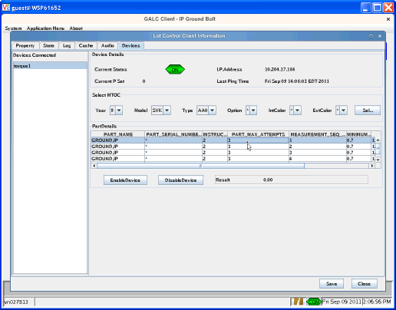

Step 9 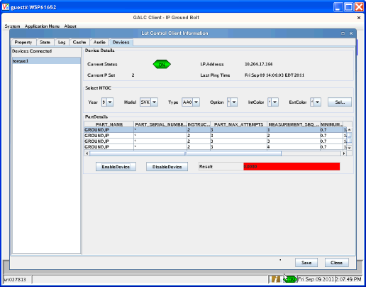

Step 10 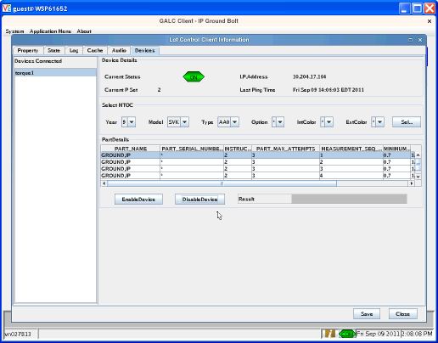

Step 11

Step 12 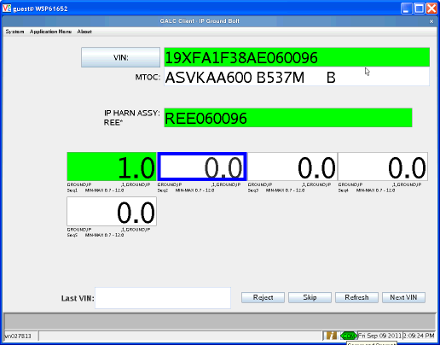

Post-Conditions
Delete the test data from the GAL234TBX, GAL246TBX, GAL214TBX, PART_SPEC_TBX, MEASUREMENT_SPEC_TBX, GAL143TBX tables.

Test Case 2 – Change to a different tab before closing the lot control client information screen

Pre-Conditions
The following Pre-Conditions should be met before executing the test:
- Data setup in GAL234TBX (Terminal Table)
- Data setup in GAL246TBX (Lot Control Rule Table)
- Data setup in GAL214TBX (Process Point Table)
- Data setup in PART_SPEC_TBX (Parts Table)
- Data setup in MEASUREMENT_SPEC_TBX (Parts Table)
- Data setup in GAL143TBX (Frame table)

Purpose:
In this test case, the working condition of the Torque Guns is tested. Using this screen the user can enable and disable the Torque Guns, collect the torque values and display them in the text box.

What’s accomplished?
The successful execution of this Test Case accomplishes the following:
- This test case tests that control of the torque controller is transferred to the main lot control screen if another tab is opened before closing the lot control information tab.

Test Steps
This section describes the steps to be taken in order to execute the test.

Step | Procedure | Expected Results | Actual Results | Pass/Fail
1 | Launch a lot control station with a torque controller | The client launches normally | As expected | Pass
2 | Click on the client information button | The lot control client information screen opens | As expected | Pass
3 | Click on the devices tab | The devices tab is displayed with a list of connected devices on the left side of the screen | As expected | Pass
4 | Select a torque device from the left side of the devices screen | The device connection information is displayed and the valid Model Year, Model Code, Model Type, Model Option, Interior Color and Exterior Color values for the process point are also auto populated in drop downs on the screen. | As expected | Pass
5 | Select the MTOC by selecting the Model Year, Model Code, Model Type, Model Option, Interior Color and Exterior Color values from their corresponding dropdowns. | The MTOC value is selected. | The MTOC value is selected. | Pass
6 | Press the “Select” Button | The Parts Names, Instruction codes for the parts, Part Serial Masks and the Minimum and Maximum torque values are displayed in the table. | The Parts Names, Instruction codes for the parts, Part Serial Masks and the Minimum and Maximum torque values are displayed in the table. | Pass
7 | Select the Part Name, for which torque value needs to be collected , from the table. | The Enable Device button , Disable Device button and Torque textbox are activated and displayed on the screen. | The Enable Device button , Disable Device button and Torque textbox are activated and displayed on the screen. | Pass
8 | Press Enable Device button | The Instruction Code is sent to the Torque Gun and Torque Gun is enabled. | The Instruction Code is sent to the Torque Gun and Torque Gun is enabled. | Pass
9 | Collect the Torque values using the Torque Gun | The Torque value is displayed in the Torque textbox. .  (Note: The Torque textbox background color changes to red or green depending on the collected torque value. If the collected torque value is with in the minimum and maximum torque value limits, the background color of the torque textbox changes to green. If the collected torque value is not with in the minimum and maximum torque value limits, the background color of the torque textbox changes to red. ) | The Torque value is displayed in the Torque textbox. .  (Note: The Torque textbox background color changes to red or green depending on the collected torque value. If the collected torque value is with in the minimum and maximum torque value limits, the background color of the torque textbox changes to green. If the collected torque value is not with in the minimum and maximum torque value limits, the background color of the torque textbox changes to red. ) | Pass
10 | Press the Disable Button | The Instruction code is sent to the Torque gun. The Torque Gun is disabled. | The Instruction code is sent to the Torque gun. The Torque Gun is disabled. | Pass
11 | Select the audio tab | The Audio tab is displayed | As expected | Pass
12 | Click on the close button | The lot control client information screen is closed and the torque controller is returned to the pset and enabled/disabled state it was in before the lot control client information screen was opened | As expected | Pass
13 | Execute the steps of the Regional Lot Control Test Plan normal flow and confirm that torques are received correctly by the normal GALC screen | Torque results appear on the main GALC lot control screen at the correct steps in the normal flow | Torques displayed correctly | Pass

Step 1 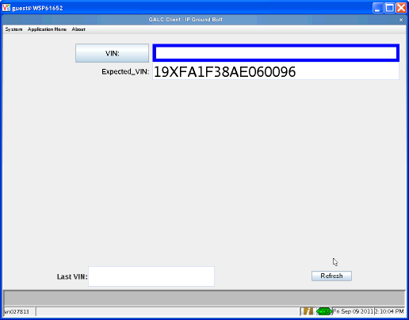

Step 2 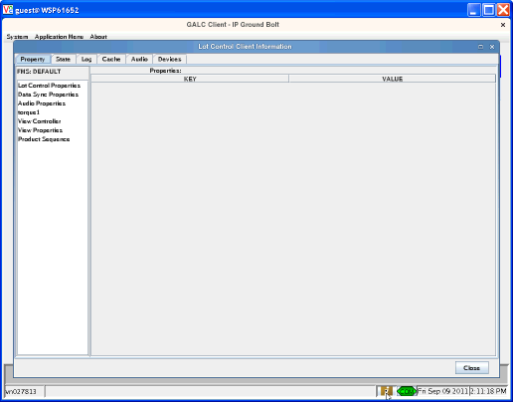

Step 3 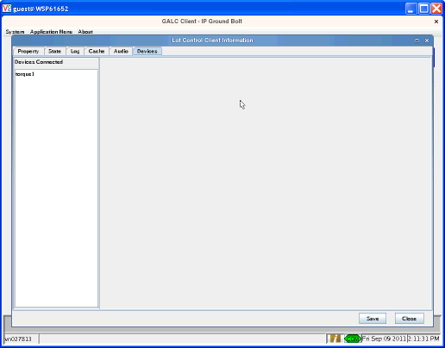

Step 4 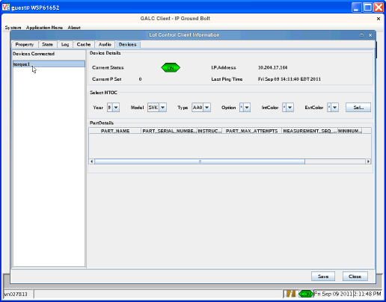

Step 6 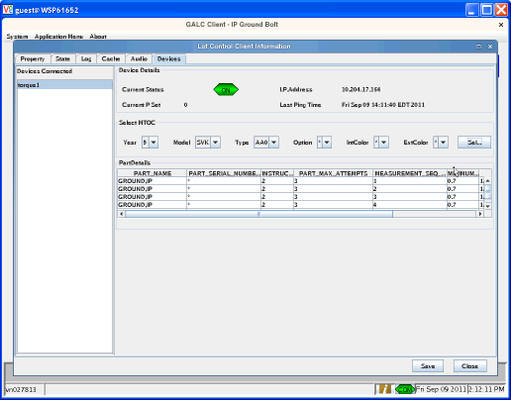

Step 7 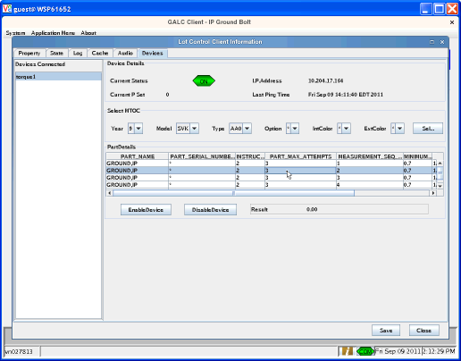

Step 8 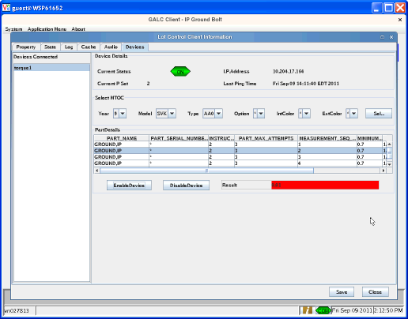

Step 10 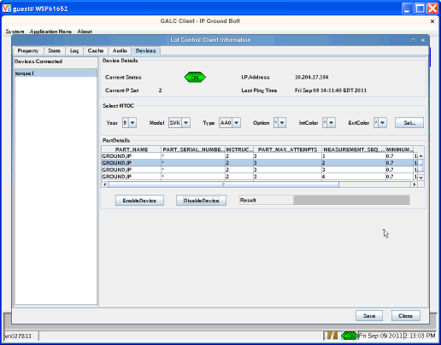

Ste p 11 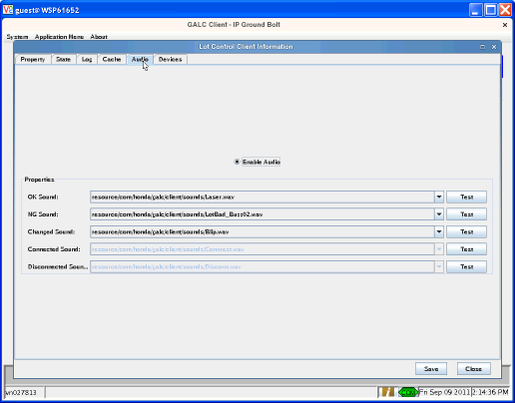

Step 12 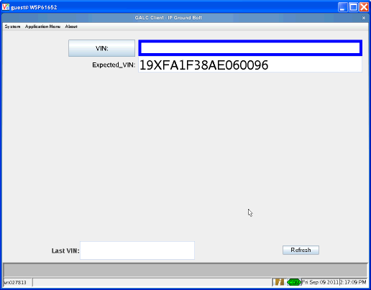

Step 13 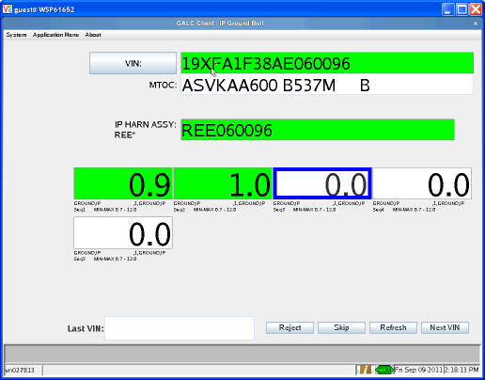

Post-Conditions
Delete the test data from the GAL234TBX, GAL246TBX, GAL214TBX, PART_SPEC_TBX, MEASUREMENT_SPEC_TBX, GAL143TBX tables.

Test Case 3 – Controller pset is reset correctly after closing the test client

Pre-Conditions
The following Pre-Conditions should be met before executing the test:
- Data setup in GAL234TBX (Terminal Table)
- Data setup in GAL246TBX (Lot Control Rule Table)
- Data setup in GAL214TBX (Process Point Table)
- Data setup in PART_SPEC_TBX (Parts Table)
- Data setup in MEASUREMENT_SPEC_TBX (Parts Table)
- Data setup in GAL143TBX (Frame table)

Purpose:
In this test case, the working condition of the Torque Guns is tested. Using this screen the user can enable and disable the Torque Guns, collect the torque values and display them in the text box.

What’s accomplished?
The successful execution of this Test Case accomplishes the following:
- This test case tests that the torque controller state is reset when the lot control test screen is closed.

Test Steps
This section describes the steps to be taken in order to execute the test.

Step | Procedure | Expected Results | Actual Results | Pass/Fail
1 | Launch a lot control station with a torque controller | The client launches normally | As expected | Pass
2 | Execute the steps of the Regional Lot Control Test Plan normal flow until the torque controller is enabled to a pset | Controller is enable with a pset | As expected | Pass
3 | Click on the client information button | The lot control client information screen opens | As expected | Pass
4 | Click on the devices tab | The devices tab is displayed with a list of connected devices on the left side of the screen | As expected | Pass
5 | Select a torque device from the left side of the devices screen | The device connection information is displayed and the valid Model Year, Model Code, Model Type, Model Option, Interior Color and Exterior Color values for the process point are also auto populated in drop downs on the screen. | As expected | Pass
6 | Select the MTOC by selecting the Model Year, Model Code, Model Type, Model Option, Interior Color and Exterior Color values from their corresponding dropdowns. | The MTOC value is selected. | The MTOC value is selected. | Pass
7 | Press the “Select” Button | The Parts Names, Instruction codes for the parts, Part Serial Masks and the Minimum and Maximum torque values are displayed in the table. | The Parts Names, Instruction codes for the parts, Part Serial Masks and the Minimum and Maximum torque values are displayed in the table. | Pass
8 | Select the Part Name, with an instruction code different than the current code. | The Enable Device button , Disable Device button and Torque textbox are activated and displayed on the screen. | The Enable Device button , Disable Device button and Torque textbox are activated and displayed on the screen. | Pass
9 | Press Enable Device button | The Instruction Code is sent to the Torque Gun and Torque Gun is enabled. | The Instruction Code is sent to the Torque Gun and Torque Gun is enabled. | Pass
10 | Collect the Torque values using the Torque Gun | The Torque value is displayed in the Torque textbox. .  (Note: The Torque textbox background color changes to red or green depending on the collected torque value. If the collected torque value is with in the minimum and maximum torque value limits, the background color of the torque textbox changes to green. If the collected torque value is not with in the minimum and maximum torque value limits, the background color of the torque textbox changes to red. ) | The Torque value is displayed in the Torque textbox. .  (Note: The Torque textbox background color changes to red or green depending on the collected torque value. If the collected torque value is with in the minimum and maximum torque value limits, the background color of the torque textbox changes to green. If the collected torque value is not with in the minimum and maximum torque value limits, the background color of the torque textbox changes to red. ) | Pass
11 | Press the Disable Button | The Instruction code is sent to the Torque gun. The Torque Gun is disabled. | The Instruction code is sent to the Torque gun. The Torque Gun is disabled. | Pass
12 | Click on the close button | The lot control client information screen is closed and the torque controller is returned to the pset and enabled/disabled state it was in before the lot control client information screen was opened | As expected | Pass

Step 2 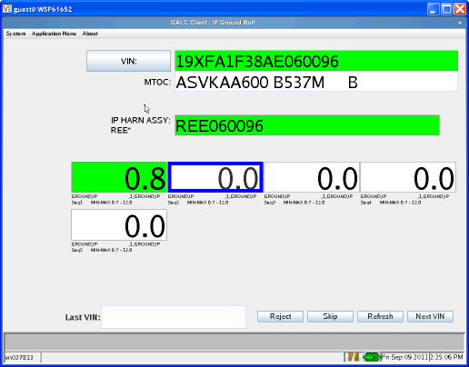

Step 3 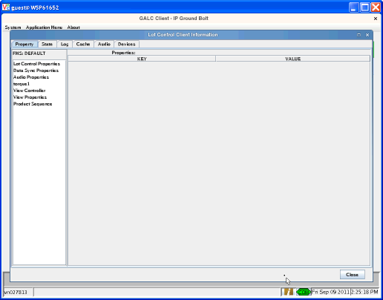

Step 4 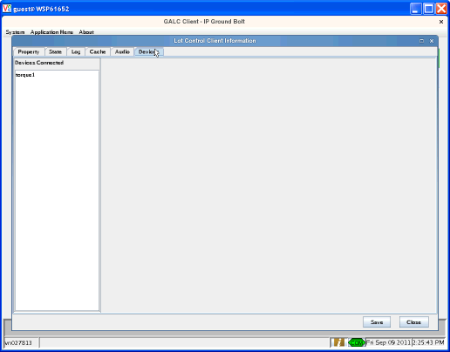

Step 5 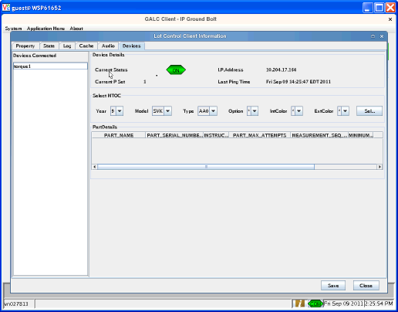

Step 7 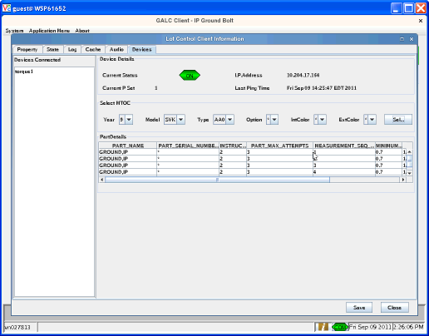

Step 8 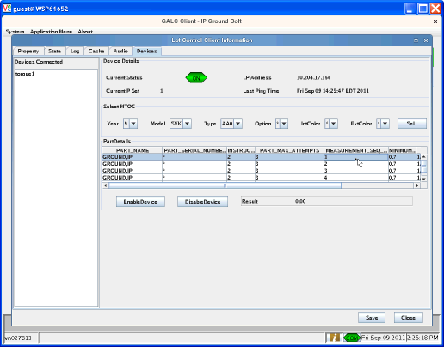

Step 9 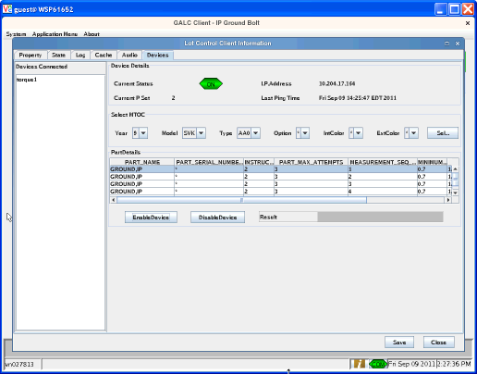

Step 10 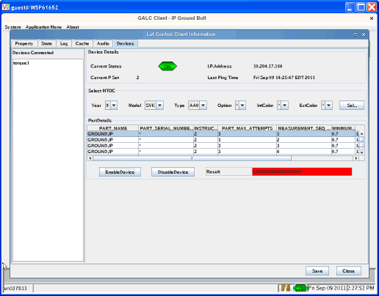

Step 11 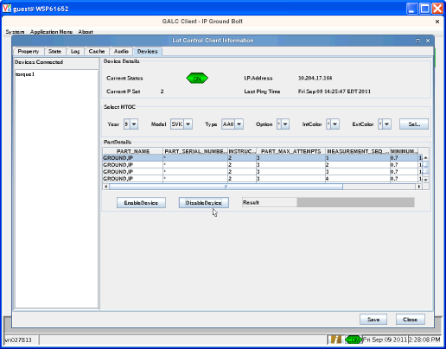

Step 12 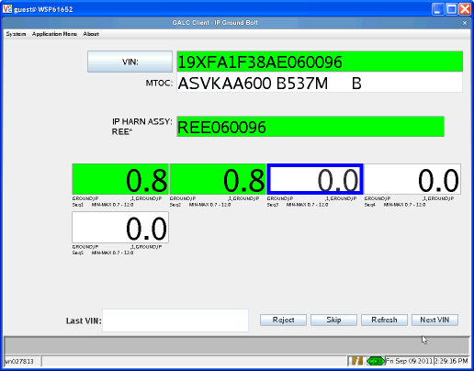

Post-Conditions
Delete the test data from the GAL234TBX, GAL246TBX, GAL214TBX, PART_SPEC_TBX, MEASUREMENT_SPEC_TBX, GAL143TBX tables.

Test Case 4 – Controller Pset is reset correctly after switching tabs before closing the test client

Pre-Conditions
The following Pre-Conditions should be met before executing the test:
- Data setup in GAL234TBX (Terminal Table)
- Data setup in GAL246TBX (Lot Control Rule Table)
- Data setup in GAL214TBX (Process Point Table)
- Data setup in PART_SPEC_TBX (Parts Table)
- Data setup in MEASUREMENT_SPEC_TBX (Parts Table)
- Data setup in GAL143TBX (Frame table)

Purpose:
In this test case, the working condition of the Torque Guns is tested. Using this screen the user can enable and disable the Torque Guns, collect the torque values and display them in the text box.

What’s accomplished?
The successful execution of this Test Case accomplishes the following:
- This test case tests that the torque controller state is reset when the lot control test screen is closed

Test Steps
This section describes the steps to be taken in order to execute the test.

Step | Procedure | Expected Results | Actual Results | Pass/Fail
1 | Launch a lot control station with a torque controller | The client launches normally | As expected | Pass
2 | Execute the steps of the Regional Lot Control Test Plan normal flow until the torque controller is enabled to a pset | Controller is enable with a pset | As expected | Pass
3 | Click on the client information button | The lot control client information screen opens | As expected | Pass
4 | Click on the devices tab | The devices tab is displayed with a list of connected devices on the left side of the screen | As expected | Pass
5 | Select a torque device from the left side of the devices screen | The device connection information is displayed and the valid Model Year, Model Code, Model Type, Model Option, Interior Color and Exterior Color values for the process point are also auto populated in drop downs on the screen. | As expected | Pass
6 | Select the MTOC by selecting the Model Year, Model Code, Model Type, Model Option, Interior Color and Exterior Color values from their corresponding dropdowns. | The MTOC value is selected. | The MTOC value is selected. | Pass
7 | Press the “Select” Button | The Parts Names, Instruction codes for the parts, Part Serial Masks and the Minimum and Maximum torque values are displayed in the table. | The Parts Names, Instruction codes for the parts, Part Serial Masks and the Minimum and Maximum torque values are displayed in the table. | Pass
8 | Select the Part Name, with an instruction code different than the current code. | The Enable Device button , Disable Device button and Torque textbox are activated and displayed on the screen. | The Enable Device button , Disable Device button and Torque textbox are activated and displayed on the screen. | Pass
9 | Press Enable Device button | The Instruction Code is sent to the Torque Gun and Torque Gun is enabled. | The Instruction Code is sent to the Torque Gun and Torque Gun is enabled. | Pass
10 | Collect the Torque values using the Torque Gun | The Torque value is displayed in the Torque textbox. .  (Note: The Torque textbox background color changes to red or green depending on the collected torque value. If the collected torque value is with in the minimum and maximum torque value limits, the background color of the torque textbox changes to green. If the collected torque value is not with in the minimum and maximum torque value limits, the background color of the torque textbox changes to red. ) | The Torque value is displayed in the Torque textbox. .  (Note: The Torque textbox background color changes to red or green depending on the collected torque value. If the collected torque value is with in the minimum and maximum torque value limits, the background color of the torque textbox changes to green. If the collected torque value is not with in the minimum and maximum torque value limits, the background color of the torque textbox changes to red. ) | Pass
11 | Press the Disable Button | The Instruction code is sent to the Torque gun. The Torque Gun is disabled. | The Instruction code is sent to the Torque gun. The Torque Gun is disabled. | Pass
12 | Select the audio tab | The Audio tab is displayed | As expected | Pass
13 | Click on the close button | The lot control client information screen is closed and the torque controller is returned to the pset and enabled/disabled state it was in before the lot control client information screen was opened | As expected | Pass

Step 2 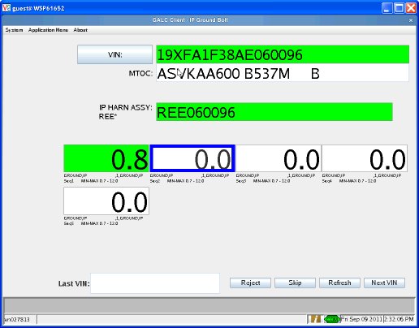

Step 3 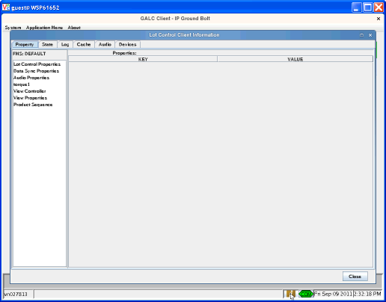

Step 4 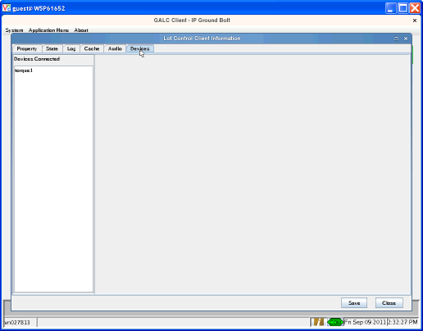

Step 5 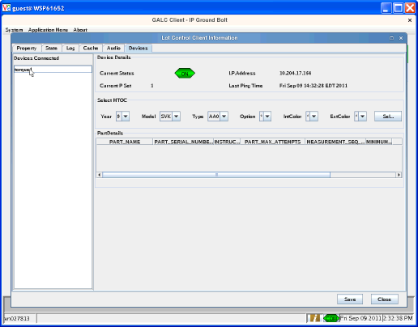

Step 7 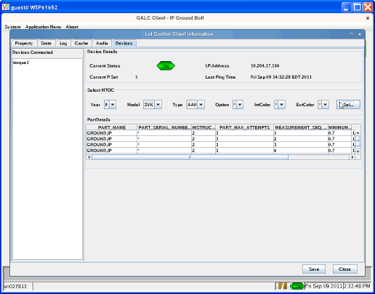

Step 8 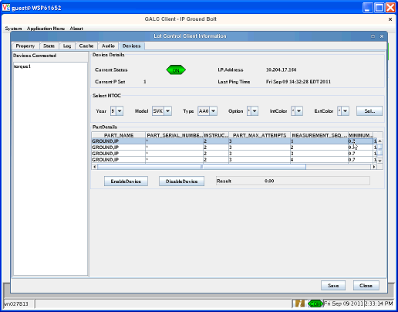

Step 9 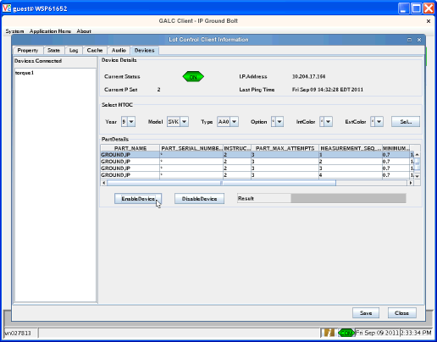

Step 10 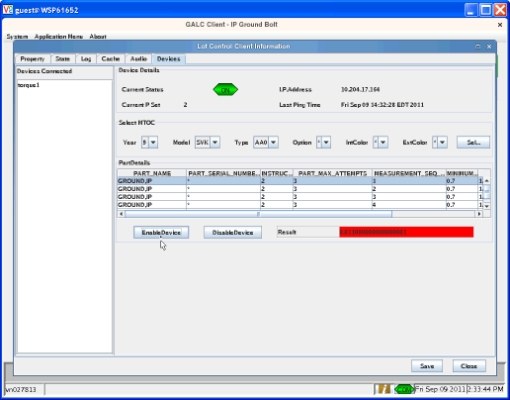

Step 11 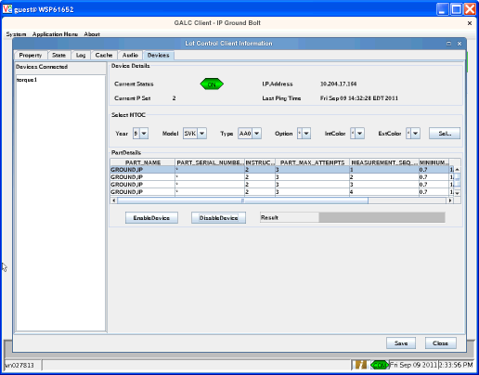

Step 12 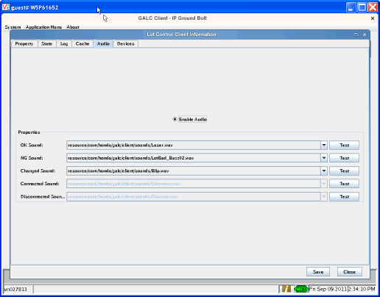

Step 13 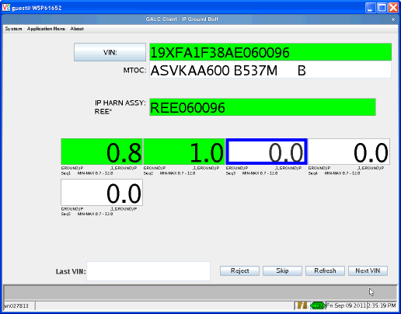

Post-Conditions
Delete the test data from the GAL234TBX, GAL246TBX, GAL214TBX, PART_SPEC_TBX, MEASUREMENT_SPEC_TBX, GAL143TBX tables.

